Distinguishing Neutron and Gamma pulses using Machine Learning and Deep Neural Network
-Kuneh Shah (22123040)
Project Duration- May 2024 to October 2024

Abstract

The Study presented here focusses on finding PSD capabilities of Machine Learning Algorithm and a Deep Learning algorithm with greater focus on Exploratory Data Analysis part. The Experiment was performed at IITR using a BC501A Liquid Scintillator with Cf-252 used as a source and digitiser. A total of 91,930 Neutron pulses and 62,728 Gamma Pulses were used which were divided randomly into testing and training data. Logistic Regression and Deep Neural Network were run side-by-side on different fast gamma and neutron (n/γ) Discrimination methods to calculate the Accuracy and FoM (Figure of Merit). Charge Comparison Method, Falling Edge Slope Method and Time domain analysis method. The analysis was done on normalised and unnormalized pulses separately to note the difference in distinguishment. The distinguishment was measured using two values - FoM and Accuracy.

Method
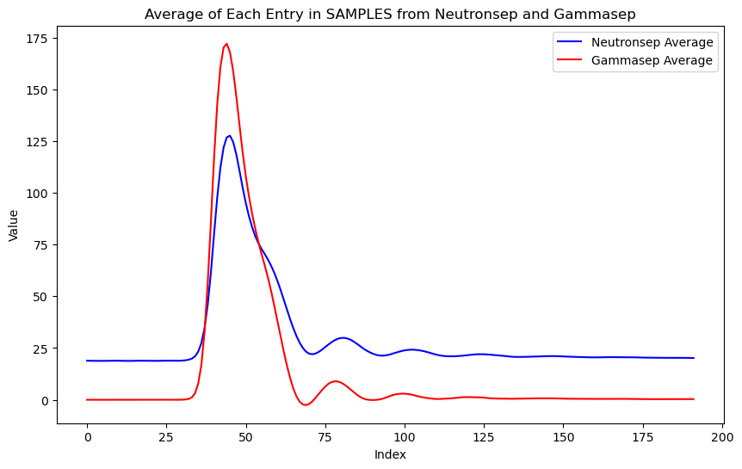
- Samples Of neutron and gamma pulses were used to plot an average over all 91930(Neutron) and 62728(gamma) datasets.

- The Offset between the two pulses was removed.
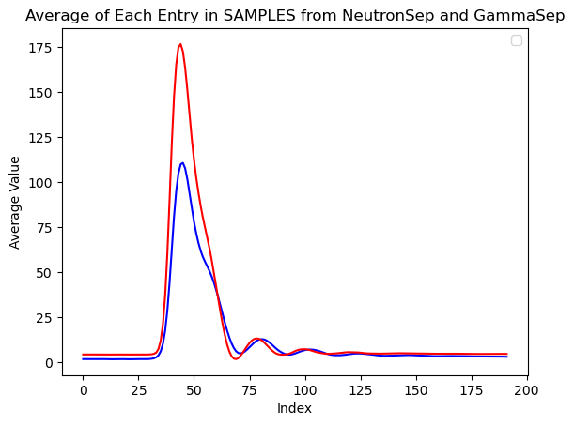

- A) The Plots were normalised to resolve the difference in peak height. *
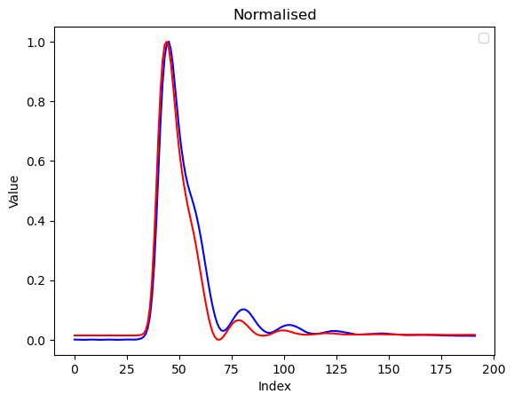

B) The plots were unnormalized (only smoothed) to keep the energy information*
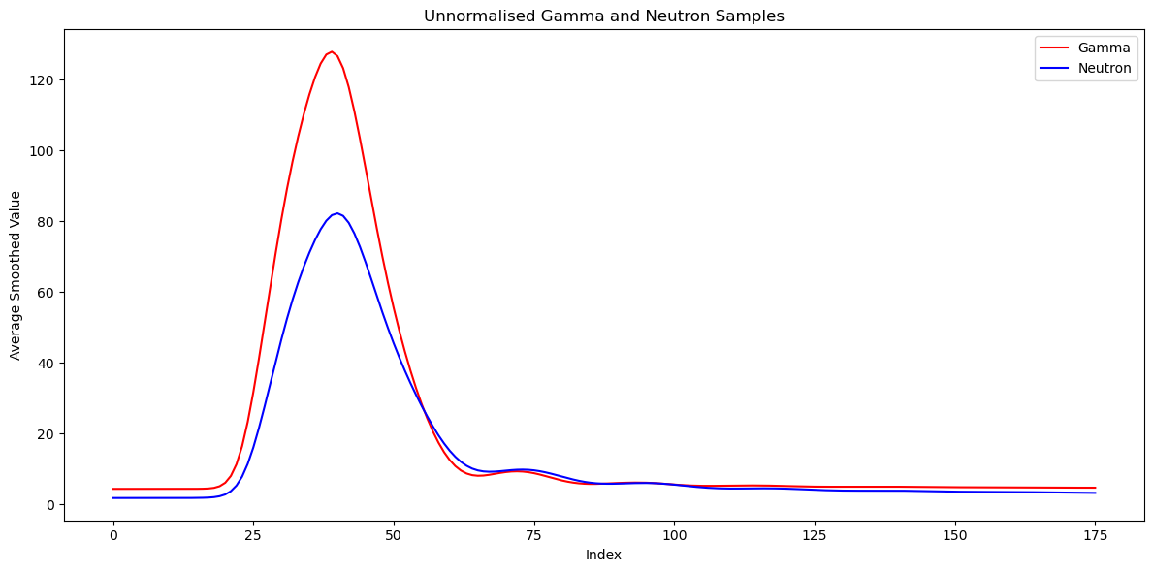
- Ringing Artifacts can be Observed near the falling edge; Hence the plot was smoothed using Moving average method with a window size of 5.
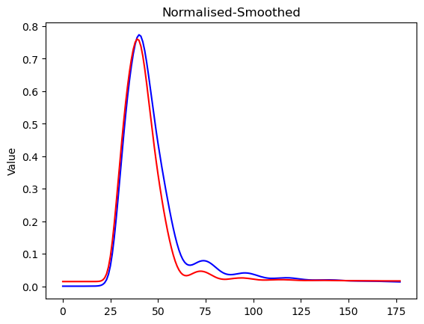
Observation:
The falling edge of Gamma is steeper than Neutron. This property can be exploited to Distinguish between Neutron and Gamma Pulses.

Analysis Methods:
The pulses provided have been pre-processed to avoid pile-up cases.

Discrimination Methods Employed:
- Charge Comparison Method (Normalized Vs Unnormalized)
- Falling Edge Slope Method (Normalized Vs Unnormalized)
- Time domain-oriented Method (Normalised vs Unnormalized)
Discrimination Parameters/Plots Employed:
- FoM (Figure of Merit)
- Scatter Plots
- Accuracy Score (Logistic Regression)
- Accuracy Score (Deep Neural Network)
Decay rate of Neutron and Gamma Pulses have also been calculated.

- Charge Comparison Method:

The Charge Comparison Method Exploits the fact that neutron and gamma pulses have different charges (Area under the plot).
$$\text{PSD}=\frac{Q_{s}}{Q_{l}} \left(\text{where }Q_{s}=\text{Tail Area, }Q_{l}=\text{Total Area}\right)$$
- Unnormalized
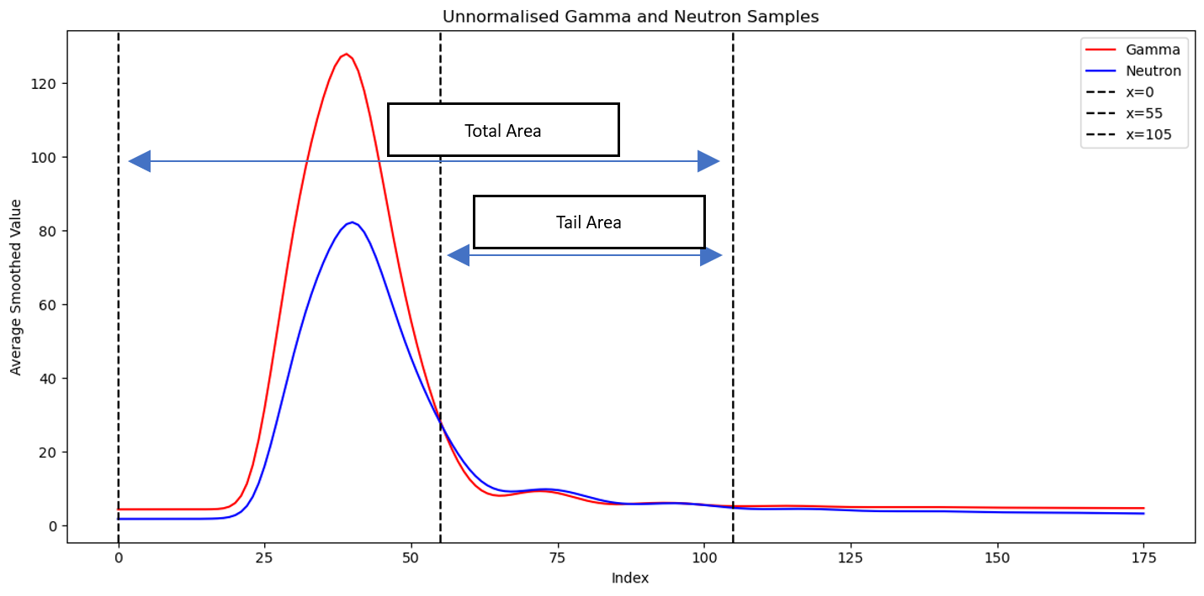
Figure 1 Qs and Ql on average plot
- Choosing Tail starting and ending time.
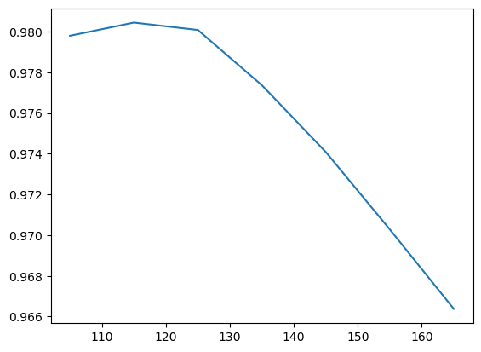
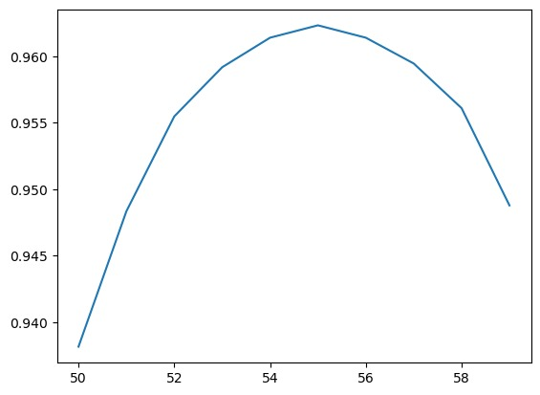
Figure 2 Accuracy Vs Tail ending time (in ns)
Figure 3 Accuracy Vs Tail Starting Time (in ns)

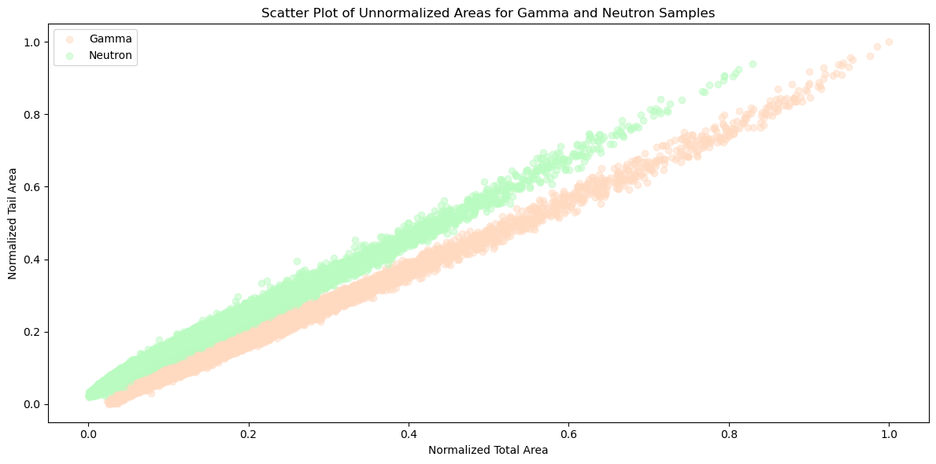
- Scatter plot for ratios: (Shows clear distinction in the ranges of ratio of tail and total areas)

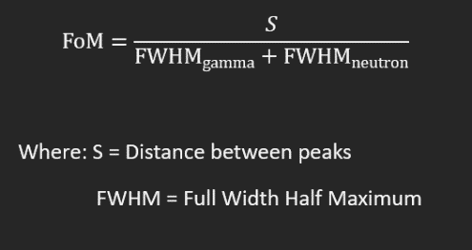
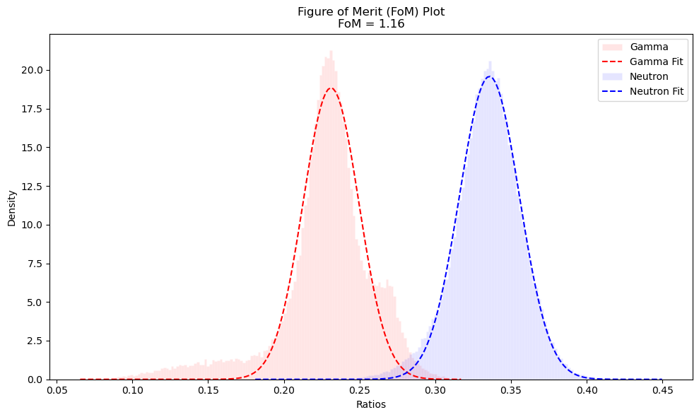
FoM plot: (FoM = 1.16)

- Accuracy Score: ( 98.1 % Discrimination Accuracy)-using Logistic Regression
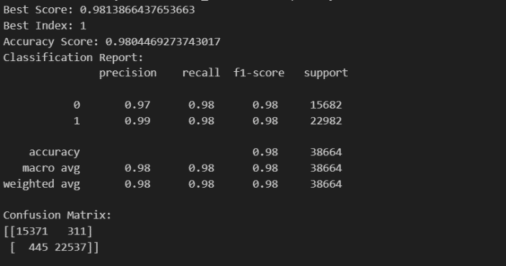

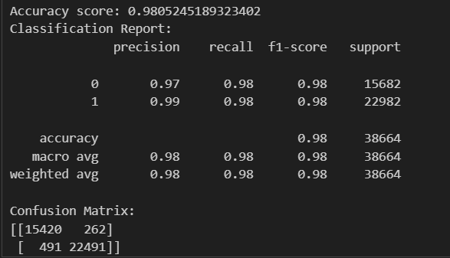
- Accuracy Score: ( 98.1 % Discrimination Accuracy)-using DNN(same hyperparameters as the paper)
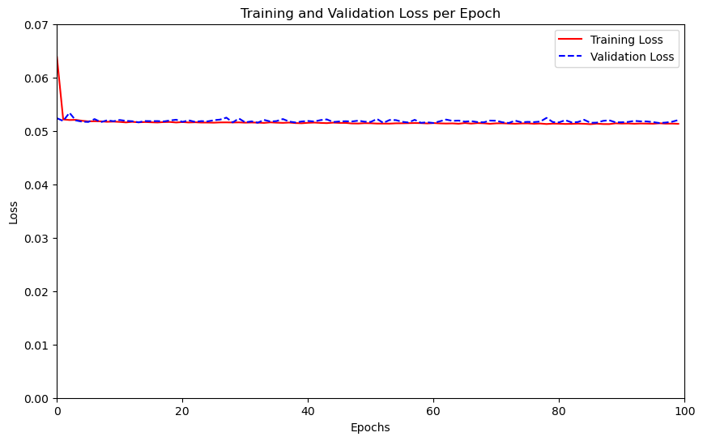

- Normalized
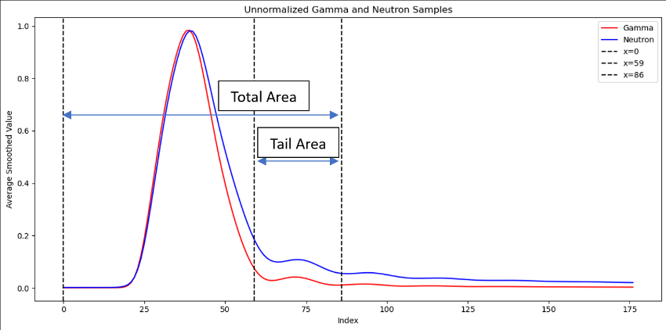

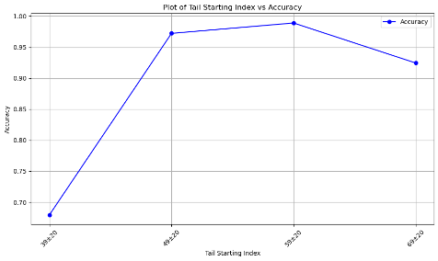
Choosing Tail starting and ending time.

Figure 4 Choosing a pivot
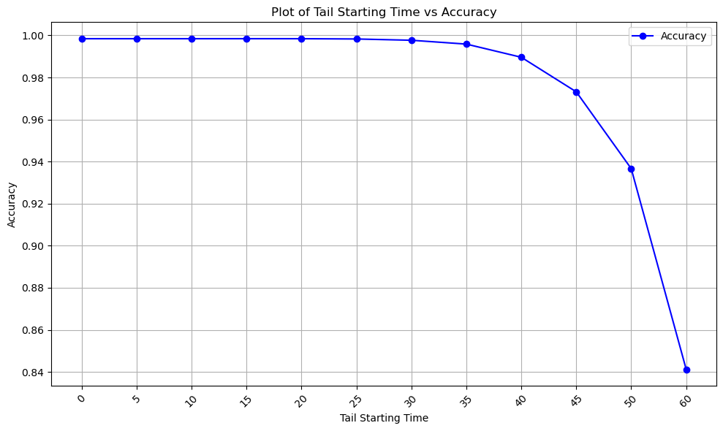
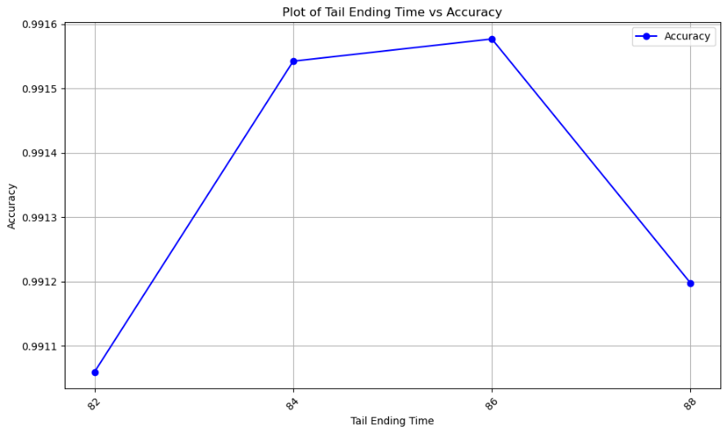
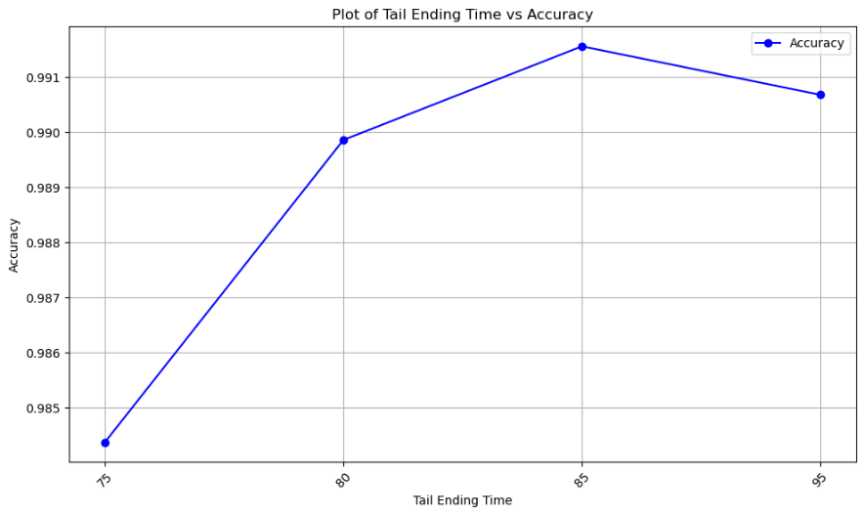
Figure 5 Choosing a Tail Starting Time(0ns-60ns)
Figure 6 Choosing a Tail Ending Time (82-88ns)
Figure 7 Choosing a Tail Ending Time(75ns-95ns)

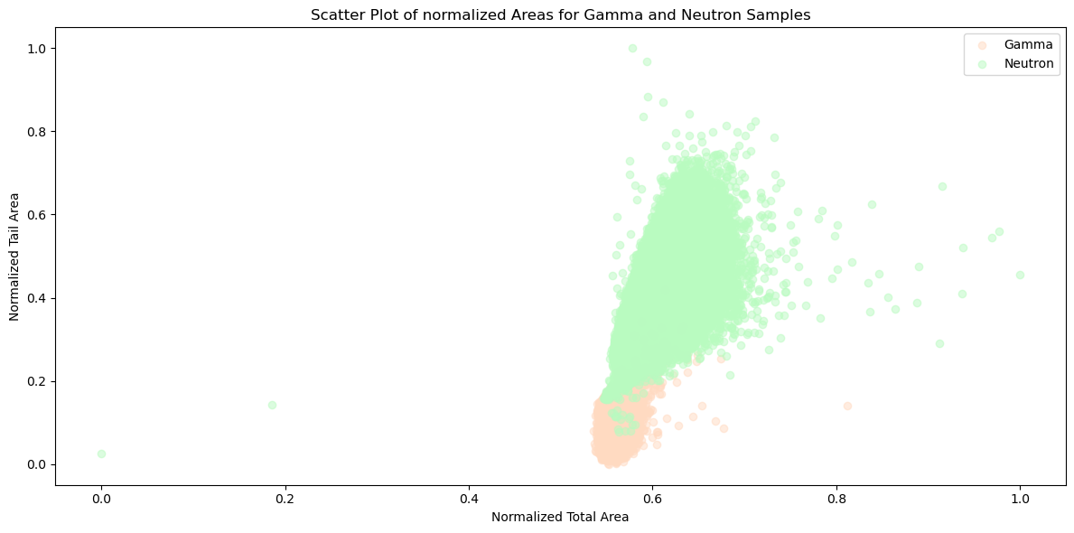
Scatter Plot
FoM Plot (FoM=1.38)
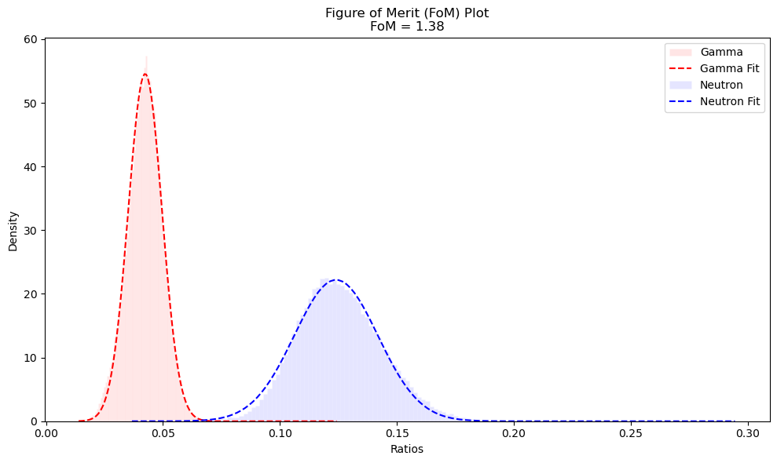

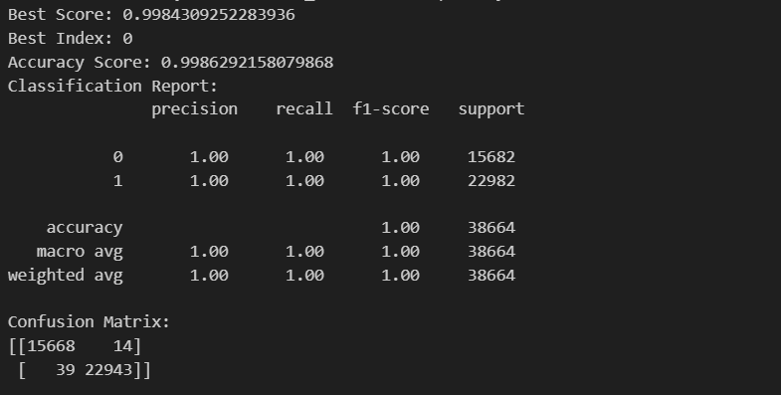
Accuracy Score: (99.84% Discrimination accuracy)-Using Logistic Regression

- Remarks:
This Document puts forth two different methods of signal processing for pulse shape discrimination.
- Offset removalSmootheningCharge Comparison
- Offset removalAmplitude NormalisationSmootheningCharge Comparison

The latter provides a much better accuracy of 99.84% compared to 98% of the former.

Some observations about the first method are;
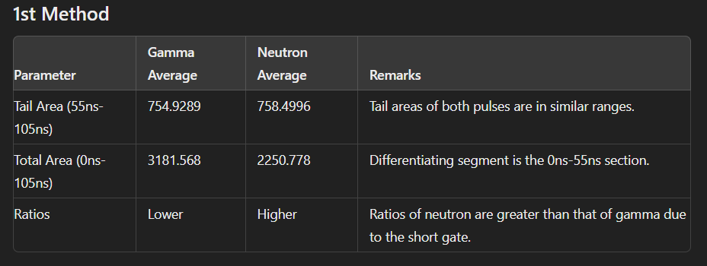The scatter plot comes out as desired but as seen by the below plot, the number of pulses breaching the classification line (for logistic regression) are 2920 out of 154656 total pulses (1.88% error) which justifies its lower accuracy.
The FoM plot(FoM=1.16-unnormalised) compared to (FoM=1.38-normalised) also reinforces 1st method’s lower accuracy.

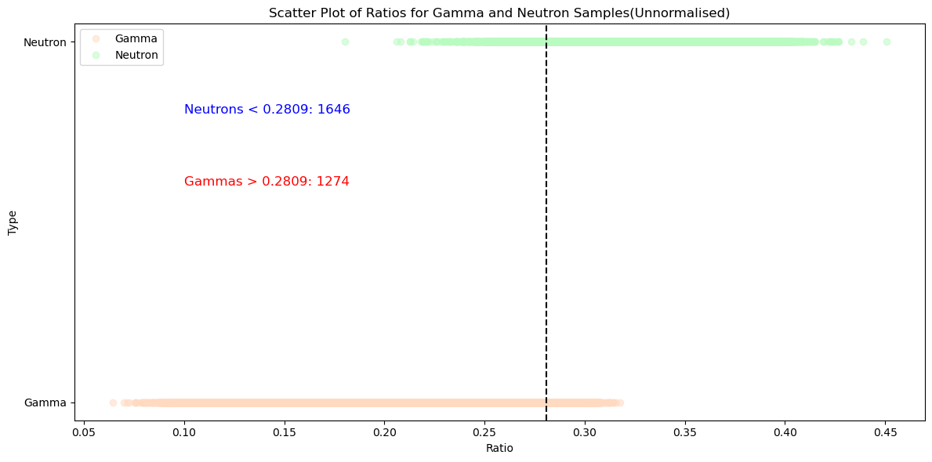

Some Observations for the 2nd Method are;
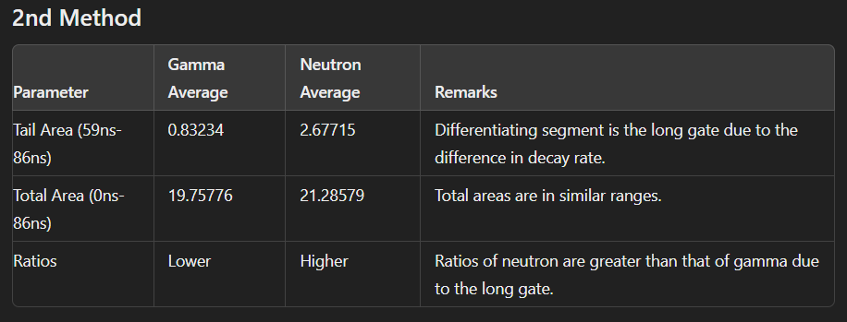The scatter plot does not come out as desired since the amplitude normalisation results in loss in variation in total area. But as seen by the below plot, the number of pulses breaching the classification line (for logistic regression) are 233 out of 154656 total pulses (0.15% error) which justifies its higher accuracy.
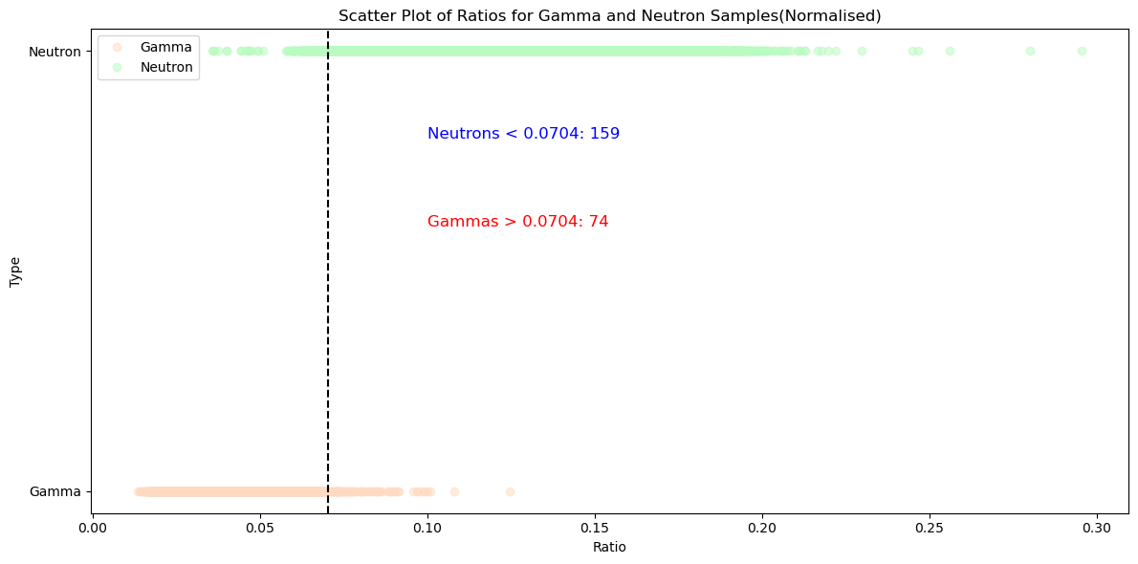

The main drawback is the fact that amplitude normalisation strips away the energy information from the input pulses of gamma and neutron. Although many articles on this topic have used normalisation in their analysis: -
- Neutron and Gamma Pulse Shape Discrimination by Robust Determination of the Decay Shape- Sergio Baselga, Eva Montbarbon
- Neutron and Gamma Ray Pulse Shape Discrimination with Polyvinyltoluene -Lintereur et al.
- The Neutron-Gamma Pulse Shape Discrimination of CLLB Detector- Ruiqiang Song et al.
- II. Falling Edge Slope Method

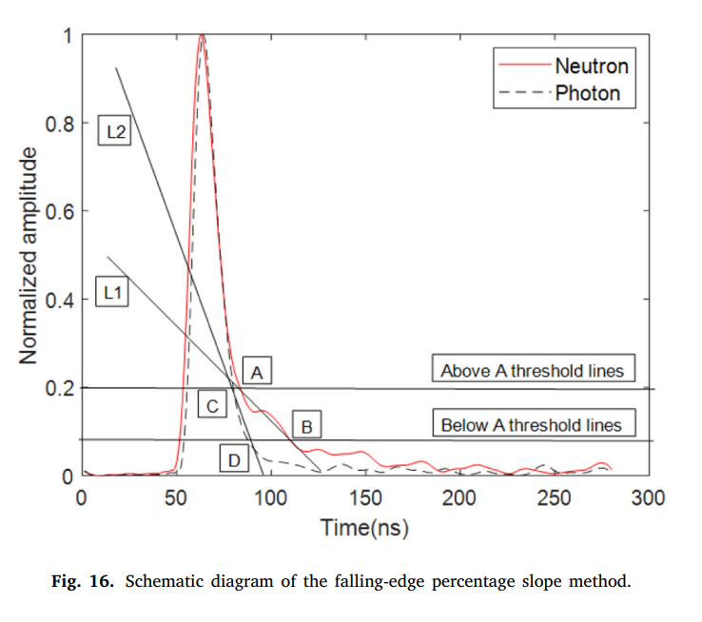

To Be Completed

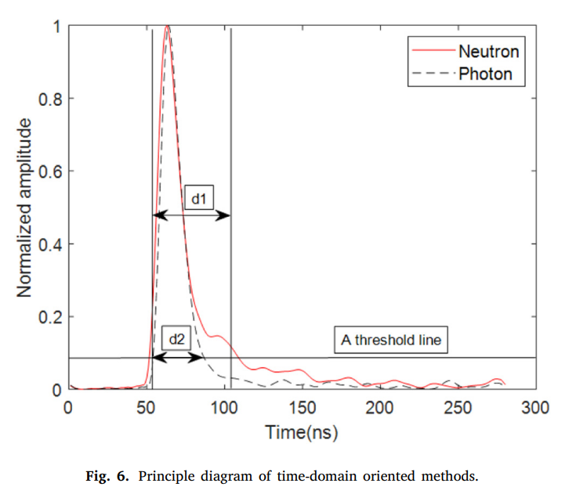
III. Time-domain oriented method

To be completed

Kaimin Wang et al.

